**Online Shopping for Gadgets**

**Domain Description**

In today's tech-driven world, gadgets have become an integral part of daily life. Gadgets could encompass various items like smartphones, laptops, tablets, smartwatches, etc. The system will include functionalities for users to browse, search, purchase, and manage orders of these gadgets.

**Relevance**

* Convenience: Consumers appreciate the convenience of browsing and purchasing gadgets online from the comfort of their homes or on-the-go.
* Wider Selection: Online platforms offer a broader range of gadgets from various brands, often presenting a more extensive selection than brick-and-mortar stores.
* Accessibility to Information: Detailed product information, specifications, user reviews, and expert opinions are readily available online.
* Competitive Pricing and Discounts: Online shopping platforms frequently offer competitive pricing due to reduced overhead costs compared to traditional retail stores.
* Convenient Payment and Delivery Options: Flexible payment methods and various delivery options, including fast shipping or store pickups, enhance the shopping experience.
* Tech Enthusiasts and Early Adopters: Gadgets attract a particular group of consumers, including tech enthusiasts and early adopters.
* Customer Reviews and Recommendations: Online shopping allows customers to access user-generated reviews and recommendations, influencing their purchasing decisions.
* Global Accessibility: Online gadget stores often provide global accessibility, enabling customers from various locations to access and purchase gadgets from anywhere in the world.
* Personalization and Recommendations: Many online platforms use algorithms and user behavior data to personalize product recommendations.

**Table Description**

Role Table

|  |  |  |
| --- | --- | --- |
| **Attribute** | **Data Type** | **Constraint** |
| RoleID | Integer | Primary Key |
| Role | String | Not Null, Unique |

User Table

|  |  |  |
| --- | --- | --- |
| **Attribute** | **Data Type** | **Constraint** |
| UserID | Integer | Primary Key |
| Username | String | Not Null, Unique |
| Email | String | Not Null, Unique |
| Password | String | Not Null |

UserRole Table

|  |  |  |
| --- | --- | --- |
| **Attribute** | **Data Type** | **Constraint** |
| UserID | Integer | Foreign Key (User(UserID)) |
| RoleID | Integer | Foreign Key (Role(RoleID)) |

Login Table

|  |  |  |
| --- | --- | --- |
| **Attribute** | **Data Type** | **Constraint** |
| LoginID | Integer | Primary Key |
| UserID | Integer | Foreign Key (User(UserID)) |
| LoginTime | DateTime | Not Null |
| LogoutTime | DateTime |  |

Seller Table

|  |  |  |
| --- | --- | --- |
| **Attribute** | **Data Type** | **Constraint** |
| SellerID | Integer | Primary Key |
| CompanyName | String | Not Null |
| CompanyAddress | String | Not Null |
| Phone | String | Not Null |

Customer Table

|  |  |  |
| --- | --- | --- |
| **Attribute** | **Data Type** | **Constraint** |
| UserID | Integer | Foreign Key (User(UserID)) |
| CustomerID | Integer | Primary Key |
| Address | String | Not Null |
| Phone | String | Not Null |

Category Table

|  |  |  |
| --- | --- | --- |
| **Attribute** | **Data Type** | **Constraint** |
| CategoryID | Integer | Primary Key |
| CategoryName | String | Not Null, Unique |
| Description | String | Not Null |

Products Table

|  |  |  |
| --- | --- | --- |
| **Attribute** | **Data Type** | **Constraint** |
| ProductID | Integer | Primary Key |
| ProductName | String | Not Null, Unique |
| CategoryID | Integer | Foreign Key (Category(CategoryID)) |
| SellerID | Integer | Foreign Key (Seller(SellerID)) |
| UnitPrice | Decimal | Not Null |

Stock Table

|  |  |  |
| --- | --- | --- |
| **Attribute** | **Data Type** | **Constraint** |
| StockID | Integer | Primary Key |
| ProductID | Integer | Foreign Key (Products(ProductID)) |
| Quantity | Integer | Not Null |

Orders Table

|  |  |  |
| --- | --- | --- |
| **Attribute** | **Data Type** | **Constraint** |
| OrderID | Integer | Primary Key |
| CustomerID | Integer | Foreign Key (Customer(CustomerID)) |
| OrderDate | DateTime | Not Null |
| TotalAmount | Decimal | Not Null |
| ShippingAddress | String | Not Null |
| Status | String | Not Null |

OrderDetails Table

|  |  |  |
| --- | --- | --- |
| **Attribute** | **Data Type** | **Constraint** |
| OrderDetailID | Integer | Primary Key |
| OrderID | Integer | Foreign Key (Orders(OrderID)) |
| ProductID | Integer | Foreign Key (Products(ProductID)) |
| Quantity | Integer | Not Null |
| SubTotal | Decimal | Not Null |

**ER Diagram**

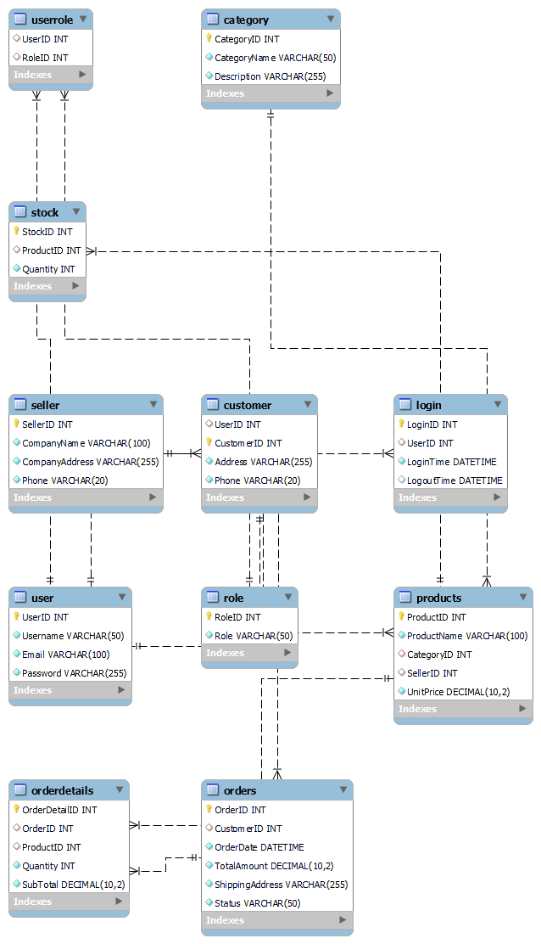

**Relationship**

* User - Role (One-to-Many):

One user can have multiple roles, but each role is associated with only one user.

* User - Login (One-to-Many):

One user can have multiple login instances, but each login is associated with only one user.

* Seller - Products (One-to-Many):

One seller can offer multiple products, but each product belongs to only one seller.

* Customer - Orders (One-to-Many):

One customer can place multiple orders, but each order is associated with only one customer.

* Category - Products (One-to-Many):

One category can contain multiple products, but each product belongs to only one category.

* Products - Stock (One-to-One/One-to-Many):

Each product may have stock information associated with it.

* Orders - OrderDetails (One-to-Many):

One order can contain multiple order details, specifying different products within that order.

**SQL Queries**

create database gadgetshopping;

use gadgetshopping;

CREATE TABLE Role (

RoleID INT PRIMARY KEY,

Role VARCHAR(50) NOT NULL UNIQUE

);

CREATE TABLE User (

UserID INT PRIMARY KEY,

Username VARCHAR(50) NOT NULL UNIQUE,

Email VARCHAR(100) NOT NULL UNIQUE,

Password VARCHAR(255) NOT NULL

);

CREATE TABLE UserRole (

UserID INT,

RoleID INT,

FOREIGN KEY (UserID) REFERENCES User(UserID),

FOREIGN KEY (RoleID) REFERENCES Role(RoleID)

);

CREATE TABLE Login (

LoginID INT PRIMARY KEY,

UserID INT,

LoginTime DATETIME NOT NULL,

LogoutTime DATETIME,

FOREIGN KEY (UserID) REFERENCES User(UserID)

);

CREATE TABLE Seller (

SellerID INT PRIMARY KEY,

CompanyName VARCHAR(100) NOT NULL,

CompanyAddress VARCHAR(255) NOT NULL,

Phone VARCHAR(20) NOT NULL

);

CREATE TABLE Customer (

UserID INT,

CustomerID INT PRIMARY KEY,

Address VARCHAR(255) NOT NULL,

Phone VARCHAR(20) NOT NULL,

FOREIGN KEY (UserID) REFERENCES User(UserID)

);

CREATE TABLE Category (

CategoryID INT PRIMARY KEY,

CategoryName VARCHAR(50) NOT NULL UNIQUE,

Description VARCHAR(255) NOT NULL

);

CREATE TABLE Products (

ProductID INT PRIMARY KEY,

ProductName VARCHAR(100) NOT NULL UNIQUE,

CategoryID INT,

SellerID INT,

UnitPrice DECIMAL(10, 2) NOT NULL,

FOREIGN KEY (CategoryID) REFERENCES Category(CategoryID),

FOREIGN KEY (SellerID) REFERENCES Seller(SellerID)

);

CREATE TABLE Stock (

StockID INT PRIMARY KEY,

ProductID INT,

Quantity INT NOT NULL,

FOREIGN KEY (ProductID) REFERENCES Products(ProductID)

);

CREATE TABLE Orders (

OrderID INT PRIMARY KEY,

CustomerID INT,

OrderDate DATETIME NOT NULL,

TotalAmount DECIMAL(10, 2) NOT NULL,

ShippingAddress VARCHAR(255) NOT NULL,

Status VARCHAR(50) NOT NULL,

FOREIGN KEY (CustomerID) REFERENCES Customer(CustomerID)

);

CREATE TABLE OrderDetails (

OrderDetailID INT PRIMARY KEY,

OrderID INT,

ProductID INT,

Quantity INT NOT NULL,

SubTotal DECIMAL(10, 2) NOT NULL,

FOREIGN KEY (OrderID) REFERENCES Orders(OrderID),

FOREIGN KEY (ProductID) REFERENCES Products(ProductID)

);

**Normalized Tables**

Role Table

|  |  |
| --- | --- |
| **RoleID** | **Role** |
| 1 | Admin |
| 2 | Seller |
| 3 | Customer |

User Table

|  |  |  |  |
| --- | --- | --- | --- |
| **UserID** | **Username** | **Email** | **Password** |
| 1 | admin1 | [admin@example.com](mailto:admin@example.com) | adminpass |
| 2 | seller1 | [seller@example.com](mailto:seller@example.com) | sellerpass |
| 3 | customer1 | [customer@example.com](mailto:customer@example.com) | customerpass |

User Role Table

|  |  |
| --- | --- |
| **UserID** | **RoleID** |
| 1 | 1 |
| 2 | 2 |
| 3 | 3 |

Login Table

|  |  |  |  |
| --- | --- | --- | --- |
| **LoginID** | **UserID** | **LoginTime** | **LogoutTime** |
| 1 | 1 | 2023-12-20 09:00:00 | 2023-12-20 17:00:00 |
| 2 | 2 | 2023-12-20 10:00:00 | 2023-12-20 16:30:00 |
| 3 | 3 | 2023-12-20 12:00:00 | 2023-12-20 15:45:00 |

Seller Table

|  |  |  |  |
| --- | --- | --- | --- |
| **SellerID** | **CompanyName** | **CompanyAddress** | **Phone** |
| 1 | SellerCo | Seller Address | 123-456-7890 |
| 2 | TechBiz | Tech Address | 987-654-3210 |

Customer Table

|  |  |  |  |
| --- | --- | --- | --- |
| **UserID** | **CustomerID** | **Address** | **Phone** |
| 3 | 1 | Customer Address | 555-123-4567 |

Category Table

|  |  |  |
| --- | --- | --- |
| **CategoryID** | **CategoryName** | **Description** |
| 1 | Electronics | Electronics Category |
| 2 | Gadgets | Gadgets Category |

Products Table

|  |  |  |  |  |
| --- | --- | --- | --- | --- |
| **ProductID** | **ProductName** | **CategoryID** | **SellerID** | **UnitPrice** |
| 1 | Laptop Pro | 1 | 1 | 999.99 |
| 2 | Smartphone X | 1 | 2 | 599.99 |
| 3 | Tablet Mini | 1 | 1 | 399.99 |

Stock Table

|  |  |  |
| --- | --- | --- |
| **StockID** | **ProductID** | **Quantity** |
| 1 | 1 | 50 |
| 2 | 2 | 100 |
| 3 | 3 | 75 |

Orders Table

|  |  |  |  |  |  |
| --- | --- | --- | --- | --- | --- |
| **OrderID** | **CustomerID** | **OrderDate** | **TotalAmount** | **ShippingAddress** | **Status** |
| 1 | 1 | 2023-12-20 13:00:00 | 999.99 | Shipping Address | Shipped |
| 2 | 1 | 2023-12-20 14:30:00 | 1199.97 | Shipping Address | Delivered |

OrderDetails Table

|  |  |  |  |  |
| --- | --- | --- | --- | --- |
| **OrderDetailID** | **OrderID** | **ProductID** | **Quantity** | **SubTotal** |
| 1 | 1 | 1 | 1 | 999.99 |
| 2 | 2 | 2 | 2 | 1199.97 |